AWS Task-1

Create a windows VM machine in AWS and connect with RDP open CMD in windows share the about system info.

Created the EC2 instance (VM) in AWS.
An AWS EC2 Windows instance is a virtual machine running Windows Server on Amazon’s cloud infrastructure.
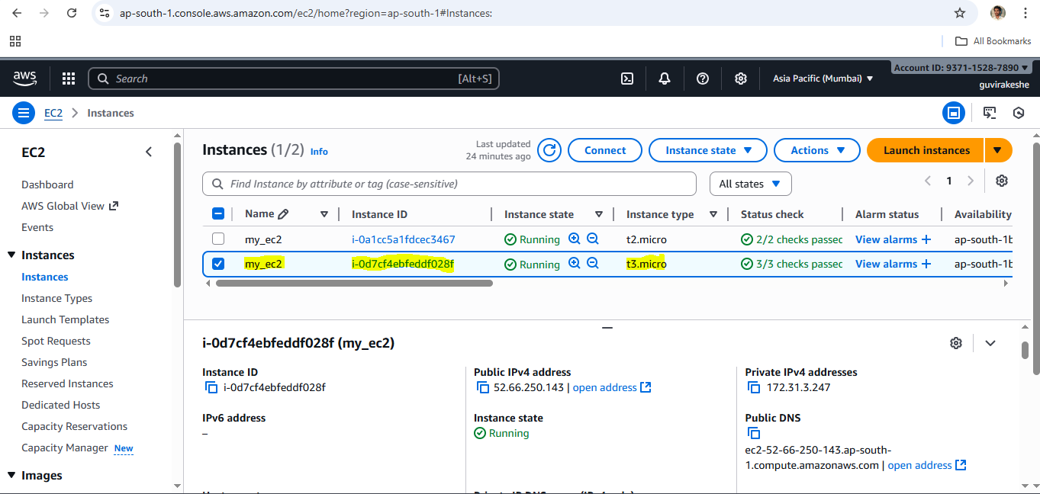
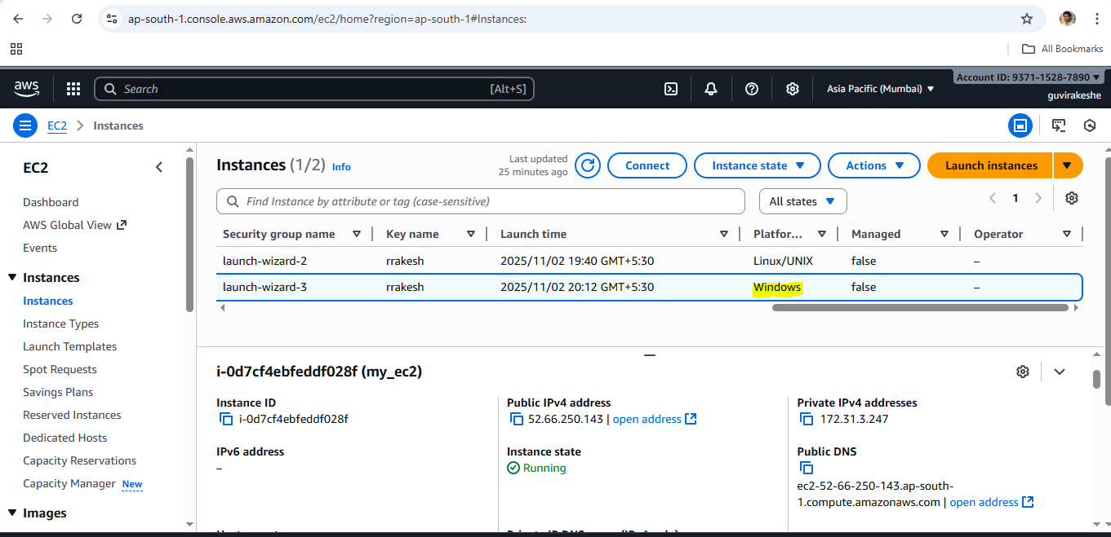

Connected with RDP open CMD in windows.
RDP (Remote Desktop Protocol) is a Microsoft protocol that allows you to remotely access and control a Windows computer over a network.
Opens Remote Desktop Connection in windows and enter the Public IP. Later enter the user name and password it will connect you to the Windows computer over a network

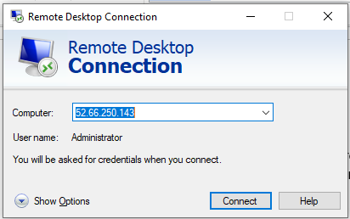

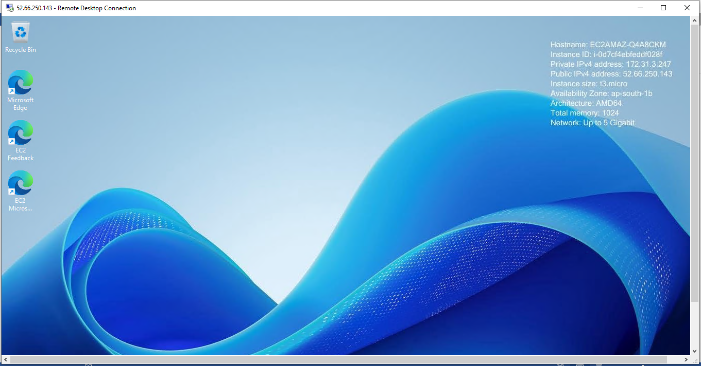

System info of the created AWS EC2 VM.
